Use the following URL to setup the Docker Virtual Disk. The rest of the page is background details to get more familure with unRAID docker but not needed
https://lime-technology.com/docker-guide/

To get the custom BrewPi Docker Image, we need to make a change to allow Docker to show results for all Docker apps. Settings -> General Settings -> Select Yes to Enable additional search results from dockerHub. Click Apply then Done.
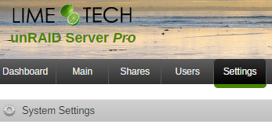
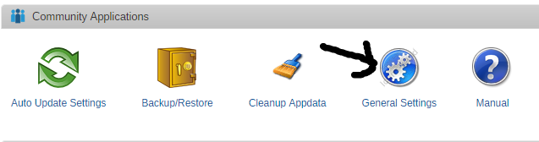
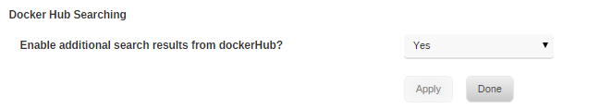

Now to search for BrewPi, under Apps and type in “BrewPi” in the search field. Once the search is done, be sure to Click “get more results from DockerHub
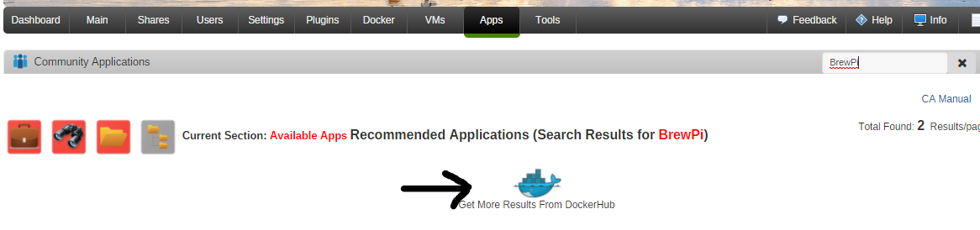
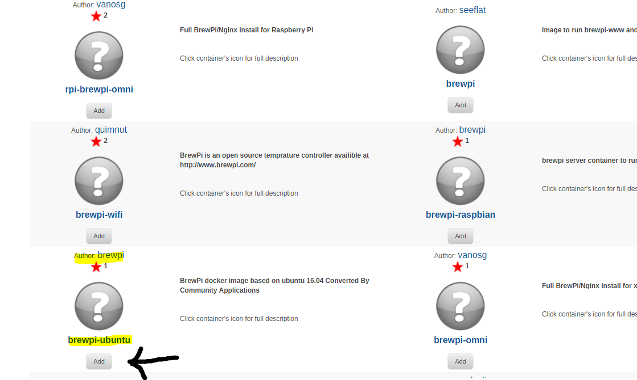Be sure to select the BrewPi docker from the author: brewpi. Click Apply

The next screen will allow us to configure BrewPi docker image. You can name the socker anything you like. Be sure to change the host port to something other than 80 as unRAID uses 80 as its default port. Click Add Another Path,Port or Variable
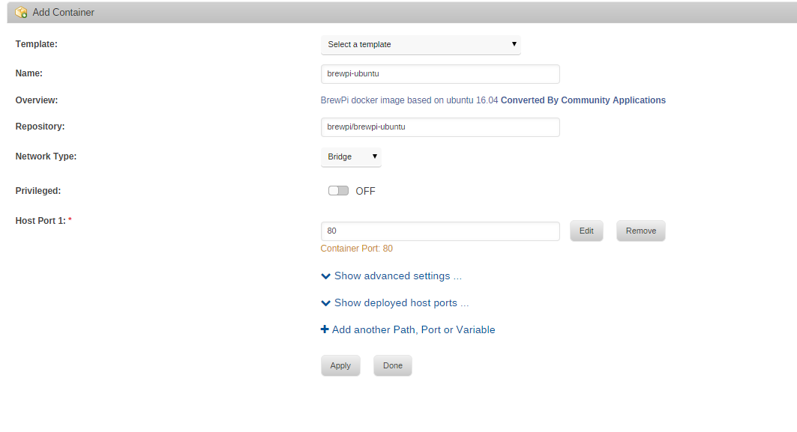

Set the Variables as shown. Once done click Add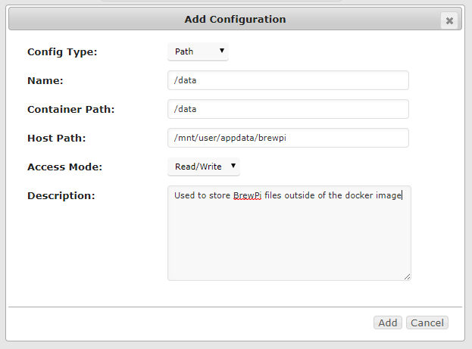
Your setting should look something like this. Click Apply
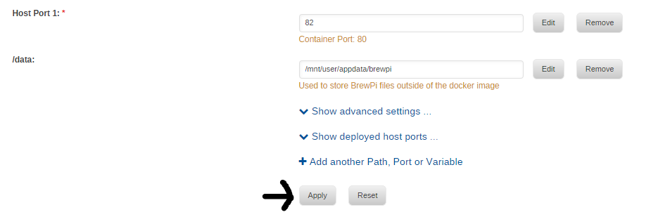

unRAID will now download all needed files and start the BrewPI docker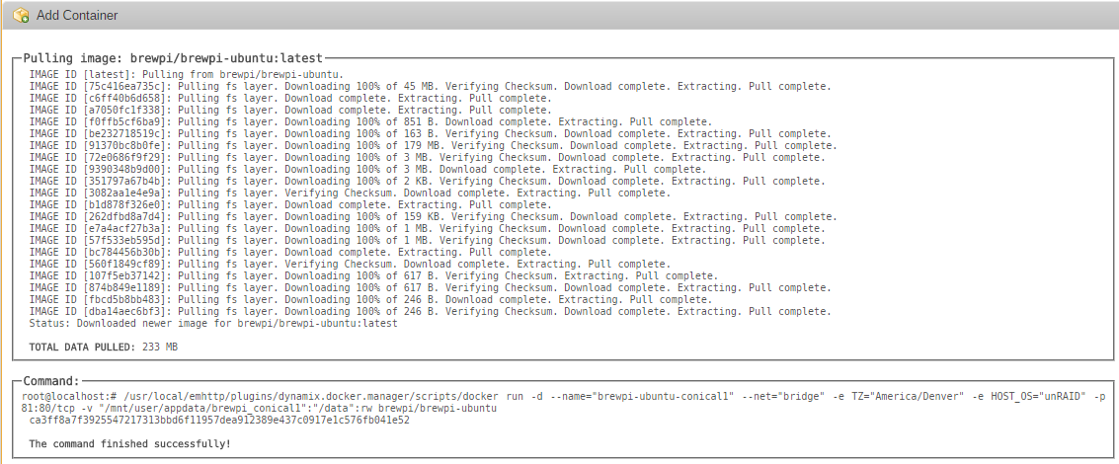
Once Complete, Click Done
If all goes well, you should now see the following. Use the Port Mapping details to either click on it to Launch BrewPi or see the URL needed to connect.
Open File browser and go to the appdata share on unRAID to set the port needed to connect to BrewPi wirelessly. \\10.1.1.251\appdata\brewpi\settings. In this folder you'll see the file config.cfg.example. Copy this file and rename it to config.cfg. In config.cfg, change the port setting to: port = socket://<ipaddress of the brewpi spark>:6666

NOTE: unRAID CLI for Dockers is rather interesting. Have to SSH into unRAID then use the following cmd to get the docker CLI. docker exec -it <container-name> /bin/bash then you can set the timezone: sudo dpkg-reconfigure tzdata. Once done type exit 2 times to close the SSH session.

